DECLARATION
I, Angafor Askia Sirri , registration number UBa25HB0688, hereby declare that this project titled Design and Implementation of a Multi-Tenant SaaS Platforme is my original work carried out in the Department of Software Engineering, The University of Bamenda in partial fulfillment of the requirements for the award of a Bachelor of Technology (BTech) degree.
I certify that this work has not been submitted, either in part or in full, for any other degree or academic qualification in this or any other institution. All sources of information used in this work have been duly acknowledged through references.
I understand the nature of plagiarism and I am fully aware of the Universities policy on academic integrity.
I therefore take full responsibility for any errors or omissions found in this work.

Date:___________________

Name: _______________________ Signature: _______________________

Name: _______________________ Signature: ____________________

CERTIFICATION

This is to certify that the project titled Design and Implementation of a Multi-Tenant SaaS Platforme was carried out by Angafor Askia Sirri ,matricule number UBa25HB0688 in the Department of Software Engineering, The University of Bamenda, in partial fulfillment of the requirements for the award of a Bachelor of Technology (BTech) in Software Engineering.

This work was conducted under the supervision of:

Supervisor:
Mr Mbiethieu Cezar

DEDICATION

I dedicate this project to My beloved mother, whose love, sacrifices, and unwavering support have been the foundation of my journey.
My supervisor, Mr Mbiethieu Cezar, for his guidance, patience, and invaluable support throughout the completion of this work.

ACKNOWLEDGEMENTS

I would like to express my sincere gratitude to the following persons for their support and contributions towards the completion of this project:
- My supervisor, Mr Mbiethieu Cezar, for his guidance, patience and continuous support throughout this work.
- The Head of Department, Dr Dada Jean-Pierre, for providing the necessary academic environment and support.
- The members of the jury, for their time, effort, and evaluation of this work.
- All my lecturers, for the knowledge and skills imparted to me during my studies.
- My beloved mother, for her love, encouragement, and unwavering support.
- My classmates, for their collaboration, encouragement, and shared academic experience.
- My friend at my internship company, for the assistance and support provided during the practical phase of this project.
I sincerely appreciate everyone who contributed directly or indirectly to the successful completion of this work.

ABSTRACT

This project presents the design and implementation of a Multi-Tenant Software-as-a-Service (SaaS) Management Platform, aimed at enabling multiple organizations to securely manage their internal operations within a shared system while maintaining strict data isolation.
The platform allows each company to create its own account and operate independently within the system. Once registered, a company can invite employees and assign them different roles such as Administrator, Manager and Staff, ensuring proper access control and responsibility management.
A key feature of the system is multi-tenancy, which ensures that each organization's data is isolated and securely separated from others, even though they are using the same application infrastructure. Each company has its own dedicated dashboard, where it can manage users, monitor activities and control its internal data without interference from other tenants.
The system enhances scalability, efficiency, and cost-effectiveness by allowing multiple organizations to share a single platform while preserving privacy and security. It also simplifies administration by providing role-based access control and centralized management tools.
This project demonstrates the practical application of cloud-based architecture and modern software development principles in building a secure and scalable SaaS solution using HTML, CSS, JavaScript and Local Storage (php and json).

Table of Contents
DECLARATION 1
CERTIFICATION 2
DEDICATION 3
ACKNOWLEDGEMENTS 4
ABSTRACT 5
CHAPTER ONE:GENERAL INTRODUCTION 9
1.1 BACKGROUND OF THE STUDY 9
1.2 PROBLEM STATEMENT 10
1.3 RESEARCH QUESTIONS 11
1.4 OBJECTIVES OF THE STUDY 12
1.5 SIGNIFICANCE OF THE STUDY 13
1.6 DEFINITION OF KEYWORDS AND TERMS 14
1.7 ORGANIZATION OF THE DISSERTATION 16
1.8 PARTIAL CONCLUSION 16
CHAPTER TWO : REVIEW OF LITERATURE 17
2.1 Introduction 17
2.2 Theoretical Framework 17
2.2.1 Generalities on Software-as-a-Service (SaaS) 18
2.2.2 Generalities on Multi-Tenant Systems 18
2.2.3 Generalities on Databases 19
2.2.4 Generalities on Database Management Systems (DBMS) 19
2.3 Empirical Frameworks 20
2.3.1 Books 20
2.3.2 Past Projects 20
2.3.3 Existing Systems 21
2.4 Conceptual Framework 21
2.4.1 Presentation of Area of Study 21
2.4.2 Presentation of Existing Systems 22
2.4.3 Advantages of Existing Systems 22
2.4.4 Limitations of Existing Systems 23
2.4.5 Objectives of the Proposed System 23
2.4.6 Advantages of the Proposed System 24
2.5 Partial Conclusion 24
CHAPTER THREE:METHODOLOGY AND MATERIALS USED 25
3.1 Introduction 25
3.2 Data Collection Methods 26
3.2.1 Observation 26
3.2.2 Questionnaire 26
3.3 System Architecture of the Proposed Platform 26
3.4 Description of System Modules 28
3.4.1 User Module 29
3.4.2 Company (Tenant) Module 29
3.4.3 Role Management Module 29
3.4.4 Dashboard Module 29
3.4.5 Data Management Module 29
3.4.6 Security Module 30
3.4.7 Communication Module 30
3.5 Working Principles of the System 30
3.6 Methods of Data Modeling 33
3.7 Application of UML to the System 33
3.8 Materials Used 37
3.8.1 Hardware Used 37
3.8.2 Software Used 37
3.9 Partial Conclusion 37
CHAPTER FOUR: RESULTS AND IMPLEMENTATION 39
4.1 Introduction 39
4.2 System Entry and User Registration 39
4.3 Company Workspace and Dashboard Structure 41
4.4 Role Definition and System Access Control 43
4.5 Administrator Functionalities 43
4.6 Manager Functionalities 44
4.7 Staff Functionalities 45
4.8 Invitation System and User Onboarding Process 46
4.9 Company Data Management and Isolation 48
4.10 System Operation Summary 49
4.11 System Testing 50
4.12USER MANUAL 51
4.13 Conclusion of Chapter Four 60
CHAPTER FIVE:CONCLUSION 62
5.1 General Conclusion 62
5.2 Contributions of the Study 62
5.3 Limitations of the System 63
5.4 Recommendations for Future Work 64
5.5 Final Statement 65
REFERENCES 66
APPENDICES 67

Figure 1system architecture 29
Figure 2flow chart 33
Figure 3use case daigram 35
Figure 4class diagram 36
Figure 5sequence diagram 37
Figure 6registration page 41
Figure 7company dash board 43
Figure 8manager dash baord 46
Figure 9worker dash board 47
Figure 10admin dashboard 49
Figure 11daily analysis 53
Figure 12generating invitation link 55
Figure 13employee login in 56
Figure 14sale history 59
Figure 15settings 61

CHAPTER ONE:GENERAL INTRODUCTION

1.1 BACKGROUND OF THE STUDY
In recent years, the rapid advancement of cloud computing and web technologies has significantly transformed the way software applications are developed, deployed and consumed. Traditional software systems which were often deployed locally for individual organizations, have gradually been replaced by more scalable, flexible, and cost-effective cloud-based solutions. One of the most prominent models that has emerged from this evolution is the Software-as-a-Service (SaaS) paradigm.
SaaS is a cloud computing model in which applications are hosted by a service provider and made available to users over the internet. Instead of installing and maintaining software on individual machines or local servers, organizations can access applications through a web browser, thereby reducing infrastructure costs, maintenance efforts, and deployment complexity. This model has become widely adopted due to its scalability, ease of access, and ability to support multiple users and organizations simultaneously.
A critical concept within SaaS architecture is multi-tenancy. Multi-tenancy refers to a software architecture where a single instance of an application serves multiple customers, also referred to as tenants, while ensuring that each tenant's data remains isolated and secure. Each tenant operates as an independent entity within the system, with its own users, configurations, and data, despite sharing the same underlying infrastructure. This approach optimizes resource utilization, reduces operational costs and simplifies system maintenance and updates.
The increasing demand for digital transformation in organizations has further accelerated the need for systems that can efficiently manage multiple users and organizational structures. Many companies especially small and medium-sized enterprises (SMEs), are adopting SaaS platforms to manage their operations due to their affordability and accessibility. Platforms such as Loyverse, which provide business management solutions for sales, inventory, and customer relationships, illustrate the practical application and benefits of SaaS systems in real-world scenarios. These systems allow businesses to operate efficiently without investing heavily in infrastructure or technical expertise.
Despite the advantages of existing SaaS platforms, there remains a need for more customizable and scalable systems that can be tailored to specific organizational requirements. Many existing solutions either lack flexibility in role management or do not fully address the need for strict data isolation between tenants. This gap presents an opportunity to design and implement a more efficient multi-tenant SaaS management platform that addresses these challenges.
Modern web development technologies such as HTML5, Tailwind CSS, JavaScript, and Local Storage have further enhanced the ability to build dynamic, responsive, and high-performance web applications. HTML5 provides a robust foundation for structuring web content with semantic elements, while Tailwind CSS offers a utility-first approach to styling that enables rapid UI development with consistent design patterns. JavaScript, as a versatile programming language, allows for dynamic client-side interactions and complex business logic implementation. Local Storage provides a client-side data persistence mechanism that enables offline functionality and efficient data management without requiring a traditional database server.
In this context, the proposed Multi-Tenant SaaS Management Platform aims to provide a centralized system where multiple companies can register, manage their users, and control their internal data within a secure and isolated environment. Each company (tenant) will have its own account, dashboard, and access control system, allowing administrators to invite employees and assign roles such as Administrator, Manager, and Staff. This role-based access control ensures that users only have access to the functionalities and data relevant to their responsibilities.
Furthermore, the platform will ensure strict data isolation between tenants, meaning that one organization cannot access or interfere with another organization's data. This is a fundamental requirement in multi-tenant systems to guarantee privacy, security, and trust. The system will also support scalability, allowing new tenants to be added without affecting existing ones, thereby making it suitable for growing organizations.
The development of this project is motivated by the need to bridge the gap between existing SaaS solutions and the growing demand for flexible, secure, and efficient multi-tenant systems. By leveraging modern web technologies and implementing robust architectural principles, this project seeks to contribute to the advancement of cloud-based application development while providing a practical solution for organizational management.
In summary, the evolution of cloud computing, the adoption of SaaS models, and the advancement of modern web technologies have created an environment where multi-tenant systems are not only necessary but essential. This project builds upon these advancements to design and implement a system that meets the needs of multiple organizations while ensuring security, scalability, and efficiency.

1.2 PROBLEM STATEMENT
With the increasing adoption of cloud-based applications, many organizations are shifting from traditional standalone systems to centralized platforms that can be accessed online. While this transition has improved accessibility and scalability it has also introduced several challenges related to data security, user management and system customization.
Most existing Software-as-a-Service (SaaS) platforms are designed to serve multiple users or organizations; however, they often lack effective mechanisms to ensure strict data isolation between different tenants. This creates potential risks where one organization's data could be accessed, manipulated, or exposed to another, thereby compromising data privacy and security. Ensuring complete separation of tenant data remains a critical challenge in multi-tenant architectures.
Additionally, many current systems provide limited flexibility in terms of user and role management. Organizations require the ability to define and assign different roles such as Administrator, Manager, and Staff, each with specific permissions and access levels. However, some existing solutions do not adequately support customizable role-based access control, making it difficult for organizations to enforce internal security policies and operational hierarchies.
Another challenge is the lack of dedicated and isolated dashboards for each organization. In many SaaS platforms, although multiple tenants can use the same system the user interface and data presentation are not always clearly separated per organization. This can lead to confusion, reduced usability and potential errors in data handling.
Further more the absence of scalable and efficient multi-tenant management systems limits the ability of organizations to grow seamlessly within a single platform. Many systems are not designed to handle the dynamic addition of new tenants without affecting performance or system stability.
There is therefore a need to develop a robust Multi-Tenant SaaS Management Platform that addresses these challenges by providing secure data isolation, efficient role-based access control, dedicated dashboards for each organization, and a scalable architecture that supports multiple tenants without compromising performance or security.
This project aims to design and implement such a system, ensuring that organizations can securely manage their internal data, control user access, and operate efficiently within a shared yet isolated environment.

1.3 RESEARCH QUESTIONS
The following research questions will guide this study:
- How can a secure multi-tenant architecture be designed to ensure strict data isolation between different organizations within a shared SaaS platform?
- What methods can be implemented to effectively manage multiple companies (tenants) within a single system while maintaining independence and security for each tenant?
- How can role-based access control (RBAC) be designed to allow organizations to define and assign roles such as Administrator, Manager, and Staff with appropriate permissions?
- In what ways can a dedicated dashboard be implemented to ensure that each organization has a clear, isolated, and user-friendly interface for managing its data?
- How can modern web technologies such as HTML5, Tailwind CSS, JavaScript, and LocalStorage be utilized to develop a scalable, efficient, and high-performance multi-tenant SaaS platform?
- What mechanisms can be put in place to ensure scalability and performance as the number of tenants and users increases within the system?
- How can the system ensure data security and privacy while allowing multiple tenants to operate simultaneously on the same infrastructure?
- What are the key challenges in developing a multi-tenant SaaS platform, and how can these challenges be addressed effectively?
These questions aim to explore the design, implementation, and evaluation of a secure and scalable multi-tenant SaaS management platform.

1.4 OBJECTIVES OF THE STUDY
General Objective
The main objective of this project is to design and implement a secure and scalable Multi-Tenant Software-as-a-Service (SaaS) Management Platform that allows multiple organizations to operate independently within a shared system while ensuring strict data isolation, efficient user management, and role-based access control.
Specific Objectives
To achieve the general objective, the following specific objectives are defined:
- To design a multi-tenant architecture that ensures complete isolation of data between different organizations using the system.
- To develop a user registration and authentication system that allows multiple companies to create and manage their own accounts securely.
- To implement a role-based access control (RBAC) system that enables organizations to assign roles such as Administrator, Manager, and Staff with different levels of permissions.
- To create a system that allows organizations to invite and manage employees within their respective tenant environments.
- To design and develop dedicated dashboards for each organization, ensuring that each tenant has a personalized and isolated interface.
- To utilize modern web technologies such as HTML5, Tailwind CSS, and JavaScript to build a responsive, efficient, and scalable user interface with client-side data persistence using Local Storage.
- To implement secure data management techniques that prevent unauthorized access and ensure data privacy across tenants.
- To ensure the system is scalable, allowing new organizations (tenants) and users to be added without affecting system performance.
- To evaluate the performance, usability, and security of the developed system to ensure it meets the requirements of a multi-tenant SaaS platform.
These objectives guide the development of the system and ensure that the final product effectively addresses the identified problems while meeting user and organizational needs.

1.5 SIGNIFICANCE OF THE STUDY
This study on the development of a Multi-Tenant SaaS Management Platform is significant to various stakeholders including businesses, developers, system administrators, and academic researchers.
- To Businesses and Organizations:
The system provides a centralized and efficient platform for managing company operations, user roles, and internal data. It enables organizations to operate independently within a shared infrastructure, reducing operational costs while improving productivity and data management.
- To Startups and Small Businesses:
The platform offers a scalable solution that allows small and growing businesses to access enterprise-level software capabilities without the need for heavy investment in infrastructure, making it cost-effective and accessible.
- To System Administrators:
The study introduces a structured approach to managing multiple tenants, user roles, and data isolation, making it easier to monitor, control, and secure different organizational environments within a single system.
- To Software Developers:
This project serves as a practical implementation of modern web development concepts such as multi-tenancy, role-based access control (RBAC), and scalable architecture using technologies like HTML5, Tailwind CSS, JavaScript, and LocalStorage. It also provides a reference model for building SaaS applications.
- To Researchers and Students:
The study contributes to academic knowledge in the field of software engineering and cloud computing by demonstrating how multi-tenant systems can be designed and implemented effectively. It also serves as a learning resource for understanding SaaS architecture and modern web application development.
- To the Software Industry:
The project aligns with current industry trends toward cloud-based and scalable solutions, highlighting best practices in building efficient, secure, and reusable systems that can serve multiple clients simultaneously.
- To the Author (me):
This study enhances practical skills in web development, system design, and software architecture, while also deepening understanding of real-world SaaS applications and modern development frameworks.
Overall, the significance of this study lies in its ability to demonstrate a functional, scalable, and efficient system that addresses the challenges of managing multiple organizations within a single software platform.

1.6 DEFINITION OF KEYWORDS AND TERMS
- SaaS (Software-as-a-Service):
A cloud computing model in which applications are hosted by a service provider and accessed by users over the internet, eliminating the need for local installation and maintenance.
- Multi-Tenancy:
A software architecture where a single instance of an application serves multiple organizations (tenants), while ensuring that each tenant's data remains isolated and secure.
- Tenant:
An individual organization or company that uses the SaaS platform and operates within its own isolated environment.
- User:
Any individual who accesses the system, belonging to a specific tenant and assigned a particular role within that tenant.
- Role-Based Access Control (RBAC):
A method of restricting system access based on user roles, where permissions are assigned according to roles such as Administrator, Manager, and Staff.
- Administrator:
A user with the highest level of access within a tenant, responsible for managing users, assigning roles, and controlling system settings.
- Manager:
A user with intermediate access rights, responsible for managing operations and overseeing certain activities within the tenant.
- Staff:
A user with limited access, primarily responsible for performing basic tasks assigned by higher-level roles.
- Dashboard:
A user interface that provides a centralized view of data, reports, and management tools for a specific tenant.
- Data Isolation:
A security mechanism that ensures data belonging to one tenant is completely separated from that of other tenants within the same system.
- Authentication:
The process of verifying the identity of a user before granting access to the system, typically through login credentials.
- Authorization:
The process of determining what actions a user is allowed to perform within the system based on their assigned role.
- Web Application:
A software application that runs on a web server and is accessed through a web browser over the internet.
- Tailwind CSS:
A utility-first CSS framework that provides low-level utility classes to build custom designs without leaving HTML, enabling rapid UI development with consistent design patterns.
- JavaScript:
A versatile programming language that enables dynamic client-side interactions, complex business logic implementation, and real-time data manipulation in web applications.
- Local Storage:
A web storage API that provides client-side data persistence, allowing applications to store data locally in the browser without requiring a traditional database server, enabling offline functionality and efficient data management.
- Scalability:
The ability of a system to handle an increasing number of users or tenants without compromising performance.
- Cloud Computing:
The delivery of computing services such as storage, processing, and applications over the internet instead of using local servers or personal devices.

1.7 ORGANIZATION OF THE DISSERTATION
This dissertation is organized into the following chapters:
- Chapter One: Introduction
This chapter presents the background of the study, problem statement, research objectives, research questions, scope, significance, and delimitation of the study. It introduces the general idea and purpose of the Multi-Tenant SaaS Management Platform.
- Chapter Two: Literature Review
This chapter reviews existing literature related to SaaS applications, multi-tenancy architecture, role-based access control, and similar systems such as Loyverse. It analyzes existing solutions, identifies gaps, and establishes the theoretical foundation of the study.
- Chapter Three: System Analysis and Design
This chapter focuses on the analysis of the current system, identification of requirements, and design of the proposed system. It includes system models such as use case diagrams, data flow diagrams, and system architecture.
- Chapter Four: System Implementation
This chapter describes the actual development of the system, including tools, technologies, frameworks, and methodologies used. It also explains how the system components were implemented.
- Chapter Five: System Testing, Evaluation and Conclusion
This chapter presents the testing of the developed system, including test cases, results, and evaluation of system performance, usability, and functionality. It also includes user acceptance testing, security testing, performance analysis, and concludes with a summary of findings, contributions, limitations, and recommendations for future work.
- References
This section lists all academic sources, books, articles, and online resources cited throughout the dissertation.
- Appendices
This section includes supplementary materials such as user manuals, system requirements, and additional technical documentation.

1.8 PARTIAL CONCLUSION
This chapter has provided an overview of the study by introducing the concept of a Multi-Tenant SaaS Management Platform and outlining the key components of the research. It has discussed the background of the study, the problem being addressed, the objectives, research questions, scope, significance, and delimitation of the study.
The foundation established in this chapter sets the basis for the subsequent chapters, where a deeper analysis, design, implementation, and evaluation of the proposed system will be carried out. The next chapter will focus on the review of existing literature and related works to provide a theoretical framework for the study.
CHAPTER TWO : REVIEW OF LITERATURE

2.1 Introduction
The literature review is a critical component of this dissertation as it provides a comprehensive examination of existing knowledge and research related to the development of a Multi-Tenant Software-as-a-Service (SaaS) Management Platform. This section highlights the purpose and significance of reviewing existing theories, systems, and technological approaches relevant to the study.
The primary purpose of the literature review is to gather, analyze, and synthesize relevant academic works, industry practices, and existing systems in order to establish a solid theoretical and practical foundation for the research. It aims to identify existing gaps, challenges, and advancements in the design and implementation of multi-tenant systems, thereby guiding the development of an improved solution.
This chapter focuses on key areas such as Software-as-a-Service (SaaS), multi-tenancy architecture, database systems, and access control mechanisms, which are fundamental to the development of modern web-based applications. It also examines existing platforms such as Loyverse to understand how similar systems operate and where improvements can be made.
The literature review is structured into three major components: the theoretical framework, which explains the underlying concepts; the empirical framework, which examines existing systems and studies; and the conceptual framework, which presents the proposed system. This chapter provides the necessary background knowledge that informs the design, implementation, and evaluation of the proposed system.

2.2 Theoretical Framework
This section presents the theoretical foundations that support the design and implementation of the Multi-Tenant SaaS Management Platform. It explores key concepts and models that guide the development of scalable, secure, and efficient web-based systems.
The theoretical framework draws from core areas such as Software-as-a-Service (SaaS), multi-tenancy architecture, database systems, and access control mechanisms. These concepts are essential in understanding how modern applications support multiple users and organizations within a shared environment while maintaining data isolation and system performance.
Understanding these theoretical frameworks enables the development of systems that are user-friendly, scalable, and secure, while also aligning with modern software engineering practices.

2.2.1 Generalities on Software-as-a-Service (SaaS)
Software-as-a-Service (SaaS) is a cloud-based software delivery model in which applications are hosted on remote servers and accessed by users over the internet. Unlike traditional software systems that require installation on local machines, SaaS applications are centrally managed and delivered through web browsers, making them highly accessible and convenient.
SaaS systems are designed to support multiple users simultaneously, offering flexibility and scalability. Organizations can use SaaS applications without investing in expensive hardware or software infrastructure, as all system maintenance, updates, and security are managed by the service provider.
A key feature of SaaS is its ability to support multiple organizations within a single system, making it ideal for business management platforms. For example, Loyverse allows different businesses to manage their operations independently while using the same platform.
Despite its advantages, SaaS systems must address challenges such as data security, system reliability, and performance. However, advancements in cloud computing technologies continue to improve the effectiveness of SaaS solutions.
In this study, SaaS forms the foundation of the proposed system, enabling multiple companies to access and manage their data through a centralized platform.

2.2.2 Generalities on Multi-Tenant Systems
Multi-tenancy is a software architecture that allows a single application to serve multiple organizations, known as tenants, while maintaining separation between their data and operations. This approach enables efficient use of system resources while ensuring that each tenant operates independently.
In a multi-tenant system, all users share the same infrastructure, but their data is logically isolated. This means that each organization can manage its own users, roles, and data without interference from other tenants.
Multi-tenancy improves scalability , as new tenants can be added without significant changes to the system. It also reduces operational costs by eliminating the need for separate systems for each organization.
However, implementing multi-tenancy requires careful consideration of data isolation, security, and performance. Mechanisms must be in place to ensure that one tenant cannot access another tenant's data.
In this project, multi-tenancy is a core feature that enables multiple companies to use the platform independently while sharing the same system infrastructure.

2.2.3 Generalities on Databases
Databases are structured systems used to store, organize, and manage data efficiently. They play a crucial role in modern applications by enabling the storage and retrieval of large volumes of data in a reliable and secure manner.
Data in databases is typically organized into tables consisting of rows and columns. This structure allows for efficient querying and data manipulation. Databases also enforce data integrity through constraints and validation rules to ensure accuracy and consistency.
Security is an important aspect of databases, as they store sensitive information such as user credentials and organizational data. Mechanisms such as authentication, authorization, and encryption are used to protect data from unauthorized access.
In multi-tenant systems, databases must support data isolation to ensure that each tenant's data is kept separate. This can be achieved through techniques such as tenant identifiers or separate database schemas.
In this study, databases are essential for storing user information, company data, and system activities in a structured and secure manner.

2.2.4 Generalities on Database Management Systems (DBMS)
A Database Management System (DBMS) is software that allows users to create, manage, and interact with databases. It provides tools for storing, retrieving, and manipulating data while ensuring data integrity and security.
The DBMS acts as an interface between users and the database, enabling efficient data operations such as querying, updating, and deleting records. It also supports multiple users accessing the database simultaneously through concurrency control mechanisms.
A DBMS ensures data consistency by enforcing rules and constraints, and it provides backup and recovery mechanisms to prevent data loss. Popular DBMSs include relational systems such as MySQL and PostgreSQL.
In web-based applications, the DBMS is responsible for handling all backend data operations. It ensures that data is stored securely and can be retrieved efficiently when needed.
In this project, the DBMS plays a vital role in managing data across multiple tenants, ensuring that each organization's data is stored securely and accessed efficiently.

2.3 Empirical Frameworks

2.3.1 Books
Books provide valuable knowledge on the design and implementation of cloud-based systems, SaaS applications, and modern web technologies. They offer both theoretical explanations and practical approaches that guide developers in building scalable and efficient systems.
According to Thomas Erl (2016), cloud computing and SaaS architectures enable organizations to deliver software services over the internet while ensuring scalability, flexibility, and cost efficiency. The book explains how shared infrastructure and service-oriented architecture contribute to the success of SaaS platforms.
Martin Fowler (2018) discusses software architecture patterns, including multi-tenancy and micro services, emphasizing the importance of designing systems that can scale and adapt to changing user requirements. His work provides insight into structuring applications that support multiple users and organizations efficiently.
Additionally, Eric Evans (2003) introduces the concept of domain-driven design, which helps developers structure complex systems by focusing on business logic and user needs. This approach is relevant in designing systems where multiple organizations interact with shared services.
These books provide a strong foundation for understanding how modern SaaS platforms are designed and implemented, and they guide the development of the proposed system.

2.3.2 Past Projects
Previous research and projects related to web-based systems and cloud applications provide valuable insights into the design and implementation of multi-user platforms.
A study by Smith et al. (2019) focused on the development of a cloud-based business management system that allowed multiple users to access shared services through a centralized platform. The study highlighted the importance of data security and user management in such systems.
Another project by Johnson and Lee (2020) explored the implementation of role-based access control in web applications. The study demonstrated how assigning roles to users improves system security and simplifies access management.
Furthermore, Nguyen (2021) developed a multi-tenant web application that supported multiple organizations within a single system. The project emphasized the importance of data isolation and efficient database design in ensuring system performance and security.
These past projects provide practical insights into the challenges and solutions associated with building multi-tenant SaaS systems, which are directly relevant to this study.

2.3.3 Existing Systems
Several existing systems demonstrate the practical implementation of SaaS and multi-tenant architectures in real-world applications.
One such system is Loyverse, a cloud-based platform that provides business management solutions such as point-of-sale, inventory management, and employee tracking. It allows multiple businesses to operate independently while using a shared system, demonstrating effective multi-tenancy and data isolation.
Another example is Shopify, an e-commerce platform that enables businesses to create and manage online stores. Shopify supports multiple tenants by allowing different businesses to manage their products, customers, and transactions within isolated environments while sharing the same infrastructure.
Additionally, Odoo is an enterprise resource planning (ERP) system that offers a wide range of business applications, including accounting, human resources, and inventory management. Odoo supports multi-tenancy and modular design, allowing organizations to customize their systems based on their needs.
These systems highlight the effectiveness of SaaS platforms in supporting multiple users and organizations. However, they also present limitations such as complexity, cost, or lack of customization for smaller businesses. These limitations create opportunities for the development of improved solutions.
The proposed system aims to build upon the strengths of these existing platforms while addressing their limitations by providing a simplified, scalable, and user-friendly multi-tenant SaaS management platform.

2.4 Conceptual Framework

2.4.1 Presentation of Area of Study
This study focuses on the design and implementation of a Multi-Tenant Software-as-a-Service (SaaS) Management Platform, a modern web-based system that allows multiple organizations to register, manage their internal operations, and control user access within a shared application environment.
The area of study lies within the domains of Software Engineering, Cloud Computing, and Web Application Development. It specifically addresses how scalable and efficient systems can be built to support multiple independent organizations (tenants) while using a single application infrastructure.
The system is designed to allow each company to create its own account, invite employees, assign roles such as Administrator, Manager, and Staff, and manage its internal data through isolated dashboards. This ensures that while all tenants share the same system, their data remains secure and inaccessible to others.
The study also explores the use of modern web technologies such as HTML5, Tailwind CSS, JavaScript, and Local Storage in building responsive and scalable user interfaces. It examines how these technologies can be combined with efficient backend and database structures to support multi-tenancy, role-based access control, and data isolation.
Overall, this area of study aims to address the growing need for centralized, scalable, and cost-effective business management systems that can serve multiple organizations simultaneously.

2.4.2 Presentation of Existing Systems
Existing systems in the domain of SaaS and business management platforms provide valuable insights into how multi-tenant applications are designed and implemented.
Systems such as Loyverse offer business management functionalities including sales tracking, inventory management, and employee monitoring. These systems allow multiple businesses to operate independently within a shared platform, demonstrating effective implementation of multi-tenancy.
Similarly, Shopify provides an e-commerce platform where different businesses can create and manage their online stores. Each business operates within its own environment while sharing the same infrastructure, highlighting the scalability of SaaS systems.
Another example is Odoo , which provides enterprise resource planning (ERP) solutions with modular features such as accounting, human resource management, and customer relationship management. Odoo supports customization and multi-tenancy, making it suitable for organizations of different sizes.
These existing systems demonstrate the effectiveness of SaaS platforms in managing multiple users and organizations. However, they often come with challenges such as complexity, high costs, or limited customization options for smaller businesses.

2.4.3 Advantages of Existing Systems
Existing SaaS platforms provide several advantages that have contributed to their widespread adoption in modern business environments.
- Scalability: These systems can support a large number of users and organizations without significant performance degradation.
- Centralized Management: Data and system operations are managed from a central location, making maintenance and updates easier.
- Accessibility: Users can access the system from any location using a web browser, improving convenience and flexibility.
- Cost Efficiency: Businesses do not need to invest in expensive hardware or software infrastructure.
- Multi-Tenancy Support: Multiple organizations can use the same platform while maintaining independent operations.
- Automation and integration: Many systems support automation of business processes and integration with other tools and services.
These advantages make SaaS platforms highly attractive for businesses seeking efficient and scalable solutions.

2.4.4 Limitations of Existing Systems
Despite their advantages, existing SaaS systems have several limitations that affect their usability and accessibility, particularly for small and medium-sized enterprises.
- Complexity: Many systems are complex and require technical knowledge to configure and manage effectively.
- High Cost: Some platforms involve subscription fees or additional costs for advanced features, making them less accessible to smaller businesses.
- Limited Customization: Users may not be able to fully customize the system to meet their specific needs.
- Data Security Concerns: Sharing infrastructure among multiple tenants raises concerns about data privacy and security.
- Performance Issues: As the number of users increases, system performance may be affected if not properly optimized.
- Dependency on Internet Connectivity: SaaS systems require stable internet access, which may not always be available.
These limitations highlight the need for improved systems that address these challenges while maintaining the benefits of SaaS architecture.

2.4.5 Objectives of the Proposed System
The proposed system aims to develop a Multi-Tenant SaaS Management Platform that addresses the limitations of existing systems while enhancing functionality and usability.
- To design a web-based platform that allows multiple organizations to register and manage their internal operations independently.
- To implement a secure multi-tenant architecture that ensures complete data isolation between tenants.
- To develop a role-based access control system that allows organizations to assign roles and manage user permissions effectively.
- To provide intuitive dashboards for managing users, data, and organizational activities.
- To ensure system scalability and performance as the number of users and tenants increases.
- To develop a user-friendly interface using modern web technologies for improved user experience.
- To create a cost-effective solution that is accessible to small and medium-sized businesses.
These objectives guide the development of the proposed system and ensure that it meets the needs of its intended users.

2.4.6 Advantages of the Proposed System
The proposed system offers several advantages over existing SaaS platforms by addressing their limitations and enhancing functionality.
- Improved Usability: The system provides a simple and intuitive interface, making it easy for users to navigate and perform tasks.
- Enhanced Data Security: Strong data isolation mechanisms ensure that each tenant's data is fully protected.
- Cost-Effectiveness: The platform is designed to be affordable, making it accessible to smaller businesses.
- Scalability: The system can support a growing number of users and organizations without performance issues.
- Centralized Management: Organizations can manage their users, roles, and data from a single platform.
- Flexibility: The system allows customization based on organizational needs.
- Efficient Role Management: Role-based access control ensures proper user authorization and security.
- Modern Technology Stack: The use of technologies such as HTML5, Tailwind CSS, JavaScript, and LocalStorage enhances performance and responsiveness.
These advantages position the proposed system as an effective and modern solution for managing multiple organizations within a single platform.

2.5 Partial Conclusion
In conclusion, this chapter has provided a comprehensive review of the literature related to the development of a Multi-Tenant SaaS Management Platform. It examined the theoretical foundations, including SaaS, multi-tenancy, databases, and access control mechanisms, which are essential for understanding modern web-based systems.
The empirical framework highlighted existing systems and previous studies, providing insights into current solutions and their limitations. The conceptual framework further analyzed these systems and presented the proposed solution, outlining its objectives and advantages.
The review demonstrates that while existing SaaS platforms offer significant benefits, they also present challenges that need to be addressed. The proposed system aims to overcome these limitations by providing a more efficient, secure, and user-friendly platform.
This chapter establishes a strong foundation for the subsequent chapters, which will focus on system analysis, design, implementation, and evaluation of the proposed system.

CHAPTER THREE :METHODOLOGY AND MATERIALS USED

3.1 Introduction
This chapter presents the methodology and materials used in the design and implementation of the Multi-Tenant SaaS Management Platform. It describes the systematic approach adopted to analyze, design, develop, and evaluate the proposed system in order to ensure that it meets its intended objectives.
The chapter also explains the rationale behind the selection of development methods, tools, frameworks, and technologies used in building the system. Since the project is a web-based application, the methodology focuses on modern software engineering practices, particularly those related to web development, cloud computing, and scalable system design.
The system is designed to allow multiple organizations to register, manage users, assign roles, and operate independently within a shared platform while maintaining strict data isolation. Therefore, the methodology emphasizes secure architecture design, efficient database management, and role-based access control.
Furthermore, this chapter outlines the development environment, tools, and programming approach used in implementing the system. It also explains how the system components interact, including the frontend, backend, and database layers.
Overall, this chapter provides a clear understanding of how the system was built, ensuring transparency and allowing future developers or researchers to replicate or improve upon the system.

3.2 Data Collection Methods
The data collection methods used in this study are essential for understanding user requirements, system needs, and functional expectations. The primary methods used include observation and questionnaires.

3.2.1 Observation
Observation involves studying how users interact with existing systems or similar platforms. In this study, observation was used to understand how organizations manage their data, how users interact with SaaS platforms, and how multi-tenant systems operate in real-world scenarios.
Through observation, it was possible to identify common challenges such as difficulty in managing multiple users, lack of role control, and issues related to data organization. This helped in designing a system that is user-friendly and efficient.

3.2.2 Questionnaire
Questionnaires were used to collect structured feedback from potential users regarding their needs and expectations from a SaaS management platform. The questionnaire included both closed and open-ended questions to gather quantitative and qualitative data.
The responses helped in identifying key features required in the system, such as user management, role assignment, dashboard customization, and secure data handling. The feedback also guided the design of the user interface and system functionalities.
These data collection methods ensured that the developed system aligns with actual user needs and expectations.

3.3 System Architecture of the Proposed Platform
The proposed Multi-Tenant SaaS Platform follows a client-side architecture that leverages modern web technologies to create a functional and scalable system. The architecture is designed to support multiple organizations (tenants) operating independently within a shared application environment.
The system architecture consists of the following layers:

Frontend Layer:
The frontend layer is built using HTML5 for semantic structure, Tailwind CSS for styling, and JavaScript for dynamic functionality. This layer provides the user interface through which users interact with the system. The frontend includes multiple pages such as the landing page (index.html), authentication page (auth.html), manager dashboard (dashboard.html), worker dashboard (worker-dashboard.html), and admin panel (admin.html).
The frontend communicates with the data layer through JavaScript functions that interact with Local Storage. All business logic is implemented in JavaScript files such as auth.js, dashboard.js, worker-dashboard.js, and admin.js.

Data Layer:
The data layer is implemented using Local Storage, a client-side web storage API that provides persistent data storage in the browser. This approach eliminates the need for a traditional database server while still providing reliable data persistence for small to medium-sized applications.
The data layer is managed through a centralized Database class (database.js) that provides a unified interface for all data operations. This class implements CRUD (Create, Read, Update, Delete) operations for all data entities including users, tenants, products, sales, employees, customers, and invitations.
Data isolation between tenants is achieved through the use of tenant identifiers. Each data entity includes a tenant Id field that associates it with a specific tenant. All data operations automatically filter results based on the current user's tenant, ensuring strict separation of data.

Security Layer:
The security layer implements authentication and authorization mechanisms to control access to the system. Authentication is performed through email and password verification, with session management using Local Storage. Authorization is enforced through role-based access control (RBAC), where users are assigned roles such as Manager, Worker, or Super Admin, each with specific permissions.
The system also implements data isolation at the database level, ensuring that users can only access data belonging to their own tenant. This tenant-scoped data access provides a strong foundation for multi-tenant security.

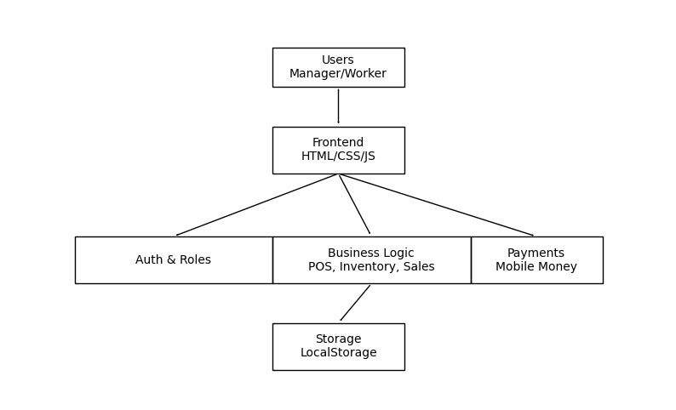
Figure 1system architecture

3.4 Description of System Modules
The system is divided into several functional modules, each responsible for specific aspects of the platform's functionality. These modules work together to provide a comprehensive business management solution.

3.4.1 User Module
The User Module handles all user-related operations including registration, authentication, profile management, and role assignment. This module ensures that users can securely access the system and perform actions based on their assigned roles.
The module includes functionality for user registration with email validation, password management, session handling, and user profile updates. It also manages the relationship between users and their respective tenants.

3.4.2 Company (Tenant) Module
The Company Module manages the creation and administration of tenant accounts. Each company that registers on the platform becomes a tenant with its own isolated environment.
This module handles tenant registration, tenant profile management, and tenant deletion. It ensures that each tenant operates independently with its own users, data, and settings.

3.4.3 Role Management Module
The Role Management Module implements role-based access control (RBAC) to define and enforce permissions for different user types. The system supports three main roles: Manager, Worker, and Super Admin.
This module manages role assignment, permission verification, and access control enforcement. It ensures that users can only access functionalities appropriate to their assigned role.

3.4.4 Dashboard Module
The Dashboard Module provides the user interface for different user types. Each role has a dedicated dashboard tailored to their specific needs and permissions.
The Manager Dashboard provides comprehensive business management tools including product management, sales tracking, employee administration, and customer relationship management. The Worker Dashboard focuses on point-of-sale operations with a product catalog, shopping cart, and checkout functionality. The Admin Panel provides platform-level oversight with business listing and marketplace management capabilities.

3.4.5 Data Management Module
The Data Management Module handles all data operations including storage, retrieval, updating, and deletion of data entities. This module ensures data integrity, consistency, and security.
The module manages data for users, tenants, products, sales, employees, customers, and invitations. It implements CRUD operations for each entity and ensures proper data relationships and cascading operations.

3.4.6 Security Module
The Security Module implements authentication, authorization, and data isolation mechanisms to protect the system from unauthorized access and ensure data privacy.
This module handles user authentication through email and password verification, session management, role-based access control enforcement, and tenant-scoped data access to ensure strict data isolation between organizations.

3.4.7 Communication Module
The Communication Module manages the invitation system for adding new users to organizations. This module provides a secure and controlled mechanism for user onboarding.
The module generates unique invitation tokens, validates invitations, manages invitation status (pending, accepted, expired), and handles the invitation acceptance process including user registration and role assignment.

3.5 Working Principles of the System
The Multi-Tenant SaaS Platform operates based on the following principles:

User Registration and Authentication:
When a new user registers on the platform, the system creates both a tenant account and a user account in a single operation. The user is automatically assigned the Manager role for their tenant. Authentication is performed through email and password verification, with session information stored in Local Storage for persistent login across browser sessions.

Multi-Tenant Data Isolation:
All data in the system is associated with a specific tenant through a tenant Id field. When data is retrieved, the system automatically filters results based on the current user's tenant, ensuring that users can only access data belonging to their own organization. This tenant-scoped data access is enforced at the database level.

Role-Based Access Control:
Users are assigned roles (Manager, Worker, Super Admin) that determine their permissions within the system. The system checks user roles before allowing access to specific functionalities, ensuring that users only perform actions appropriate to their responsibilities.

Invitation-Based Onboarding:
Managers can invite new employees to their organization by generating unique invitation tokens. When an invited user accepts the invitation, they are automatically registered and assigned the specified role within the inviting tenant. This provides a controlled and secure onboarding process.

Client-Side Data Persistence:
The system uses LocalStorage for data persistence, allowing the application to function offline after initial page load. This approach simplifies deployment and reduces infrastructure requirements while providing reliable data storage for small to medium-sized applications.
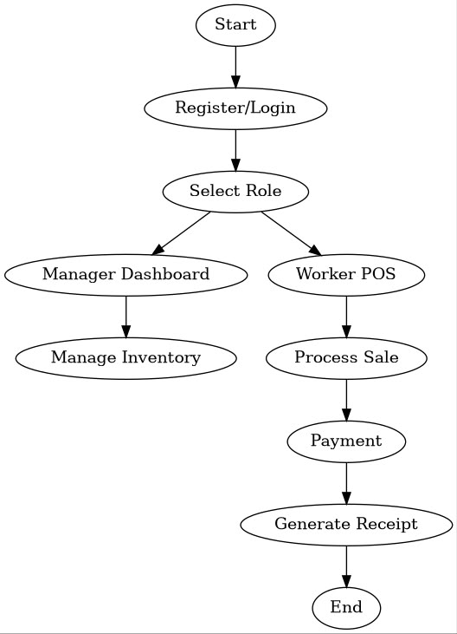
Figure 2flow chart

3.6 Methods of Data Modeling
The system uses an object-oriented approach to data modeling, with each data entity represented as an object with specific properties and methods. The main data entities include:
- User: Represents a system user with properties such as id, tenant Id, name, email, password, role, and created At
- Tenant: Represents an organization with properties such as id, name, email, and created At
- Product: Represents an inventory item with properties such as id, tenant Id, name, price, stock, category, barcode, and created At
- Sale: Represents a transaction with properties such as id, tenant Id, items, total, customer Name, payment Method, and created At
- Employee: Represents a staff member with properties such as id, tenant Id, name, email, role, and created At
- Customer: Represents a client with properties such as id, tenant Id, name, email, phone, and created At
- Invitation: Represents an invitation to join an organization with properties such as id, tenant Id, token, email, role, status, created At, and expires At

Data relationships are maintained through tenant associations, ensuring that all data belonging to a specific tenant is properly linked and can be retrieved efficiently.

3.7 Application of UML to the System
Unified Modeling Language (UML) diagrams are used to visualize the system design and structure. The following UML diagrams were created for the system:

Use Case Diagram:
The use case diagram illustrates the interactions between different user types (Manager, Worker, Super Admin) and the system functionalities. It shows the actions each user can perform within the system, such as registering, logging in, managing products, processing sales, and managing employees.
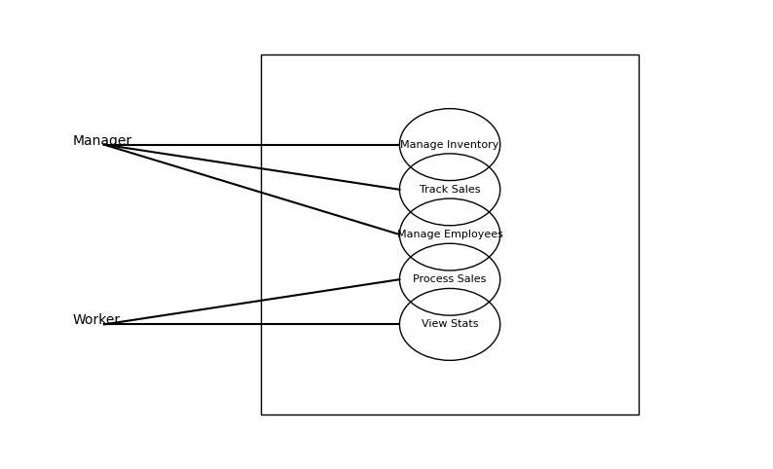
Figure 3use case diagram

Class Diagram:
The class diagram represents the static structure of the system, showing the classes (entities), their attributes, methods, and relationships. It illustrates how different data entities relate to each other through associations and dependencies.

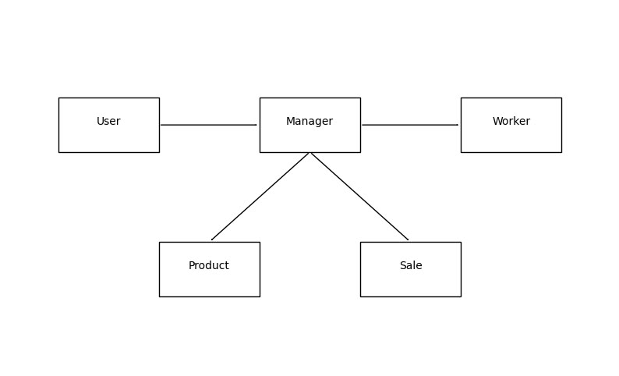
Figure 4class diagram

Sequence Diagram:
The sequence diagram illustrates the dynamic behavior of the system by showing the sequence of interactions between objects over time. It demonstrates how users interact with the system during operations such as registration, authentication, and sales processing.

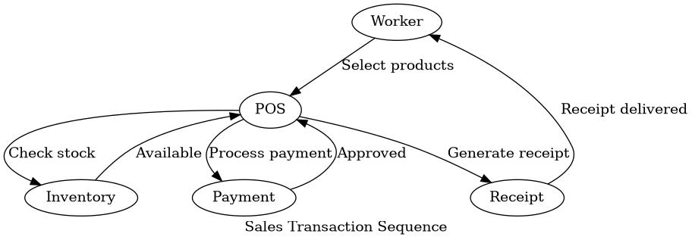
Figure 5sequence diagram

3.8 Materials Used

3.8.1 Hardware Used
The development of the system required the following hardware:
- Computer
- High-speed internet connection for accessing online resources and testing web functionality
- Modern web browser (Google Chrome)

3.8.2 Software Used
The following software tools and technologies were used in the development of the system:
- HTML5: For structuring web pages with semantic elements
- CSS: For styling and creating responsive user interfaces
- JavaScript: For implementing business logic and dynamic functionality
- Local Storage API: For client-side data persistence
- Visual Studio Code: As the integrated development environment (IDE) for writing and editing code
- Google Chrome: For testing and debugging the application
- Git: For version control and code management
- GitHub: For remote repository hosting and collaboration

The selection of these tools and technologies was based on their suitability for the project requirements, ease of use, availability of documentation and community support, and compatibility with modern web standards.

3.9 Partial Conclusion
This chapter has presented the methodology and materials used in the design and implementation of the Multi-Tenant SaaS Management Platform. It described the data collection methods, system architecture, module descriptions, working principles, data modeling approach, UML diagrams, and the hardware and software tools used.
The methodology adopted ensures that the system is developed systematically, following established software engineering practices. The use of modern web technologies such as HTML5, Tailwind CSS, JavaScript, and Local Storage provides a solid foundation for building a functional, scalable, and efficient multi-tenant platform.
The next chapter will present the detailed implementation of the system, including the actual development process, code structure, and functional outcomes.

CHAPTER FOUR: RESULTS AND IMPLEMENTATION

4.1 Introduction
This chapter presents the detailed implementation and functional outcomes of the Askia Multi-Tenant SaaS Platform. It describes how the system was developed using modern web technologies, the specific features implemented, and how the system operates in practice.
The implementation phase involved translating the design specifications from Chapter Three into a working web application. This included developing the user interfaces, implementing business logic, setting up data management, and ensuring proper security measures.
The chapter provides a comprehensive overview of the implemented system, including the technology stack used, the architecture implemented, and the specific functionalities available to different user types. It also demonstrates how the system achieves multi-tenancy, role-based access control, and data isolation.

4.2 System Entry and User Registration
The Askia Multi-Tenant SaaS Platform begins with a landing page (index.html) that serves as the entry point for new users. The landing page provides information about the platform and offers options for users to either sign in to an existing account or register for a new account.
When a user chooses to register, they are directed to the authentication page (auth.html) which contains a registration form. The registration form collects essential information including the user's full name, email address, business name, and password. This information is used to create both a tenant account and a user account in a single operation.
The registration process validates that the email address is not already registered in the system. If the email is unique, the system creates a new tenant with the provided business name and email, then creates a user account associated with this tenant. The user is automatically assigned the Manager role, giving them full control over their newly created business workspace.
Upon successful registration, the user is automatically logged in and redirected to the manager dashboard (dashboard.html). This seamless transition ensures that new users can immediately begin using the platform without additional steps.

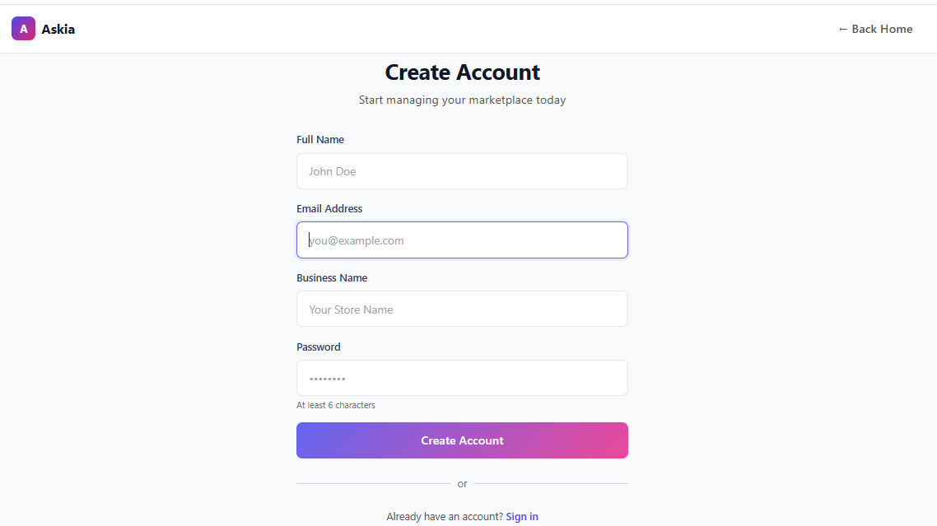
Figure 6registration page

4.3 Company Workspace and Dashboard Structure
Once registered and logged in, users access their company workspace through role-specific dashboards. The system implements three main dashboards tailored to different user types: the Manager Dashboard, the Worker Dashboard, and the Admin Panel.
The Manager Dashboard (dashboard.html) provides a comprehensive business management interface with tab-based navigation. The tabs include Overview, Products, Sales, Employees, Invitations, and Customers. Each tab provides specific functionality for managing different aspects of the business.
The Overview tab displays key business statistics including total revenue, number of sales, active products, and employee count. It also provides quick action buttons for common tasks such as adding products, creating sales, or inviting employees.
The Products tab allows managers to create, edit, and delete inventory items. Each product can be assigned a name, price, stock quantity, category, and barcode. The system automatically generates barcodes for products using the Js Barcode library.
The Sales tab displays a complete history of transactions with details such as sale date, customer name, items purchased, total amount, and payment method. Managers can view individual sale details and generate receipts with QR codes using the QR Code library.
The Employees tab enables managers to invite new team members to the organization. Managers can enter employee email addresses, select roles (worker or manager), and generate unique invitation links. The tab also displays a list of current employees with their roles and status.
The Invitations tab shows all invitations sent by the organization, categorized by status (pending, accepted, expired). Managers can resend pending invitations or revoke invitations that are no longer needed.
The Customers tab allows managers to create and manage customer profiles, including contact information and purchase history.

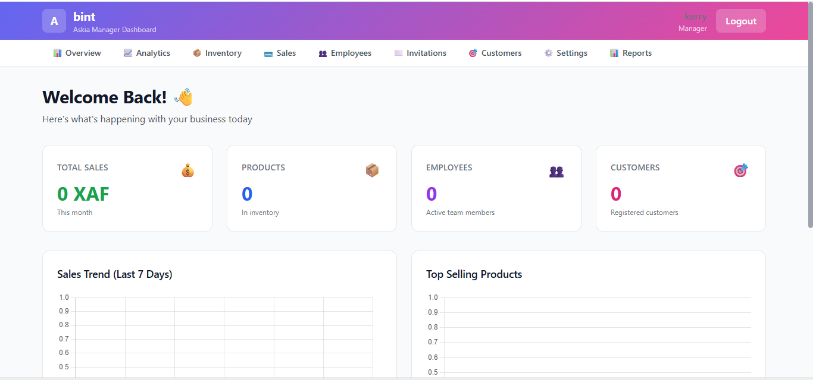
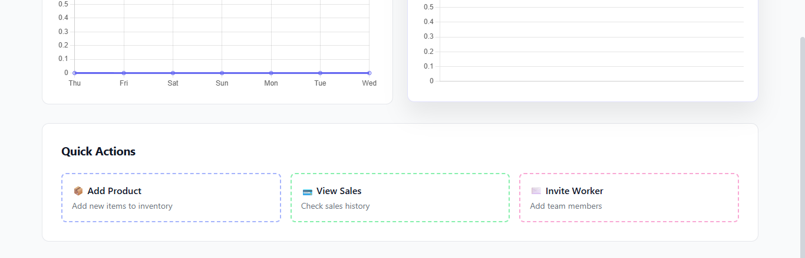
Figure 7company dash board

4.4 Role Definition and System Access Control
The Askia platform implements a three-tier role-based access control system to ensure proper security and operational efficiency. The three main roles are Manager, Worker, and Super Admin, each with distinct permissions and responsibilities.
The Manager role represents the highest level of access within a tenant organization. Managers have full control over business operations including product management, sales tracking, employee administration, customer relationship management, and invitation controls. Managers can also invite new users and assign roles within their tenant.
The Worker role is designed for employees who perform point-of-sale operations. Workers have access to the Worker Dashboard where they can browse products, add items to a shopping cart, process sales transactions, and view their sales history. Workers do not have access to administrative features such as product management, employee management, or comprehensive sales reports.
The Super Admin role provides platform-level oversight capabilities. The Super Admin can access the Admin Panel (admin.html) to view all registered businesses, monitor platform statistics, and delete marketplaces when necessary. This role is separate from tenant roles and is used for platform administration rather than business operations.
Role assignments are enforced at multiple levels in the system. When users log in, the system checks their role and redirects them to the appropriate dashboard. Before allowing access to specific functionalities, the system verifies that the user has the required permissions. This multi-layered enforcement ensures that users can only perform actions appropriate to their assigned role.

4.5 Administrator Functionalities
Within each tenant organization, the Manager serves as the administrator with comprehensive control over business operations. The Manager Dashboard provides a full suite of administrative tools designed to enable efficient business management.
The Overview tab serves as a command center, displaying real-time statistics that help managers monitor business performance at a glance. The statistics are calculated dynamically from the Local Storage database and update automatically as data changes.
Product management functionality allows managers to maintain their inventory efficiently. Managers can add new products with complete information including name, price, stock quantity, and category. The system automatically generates unique barcodes for each product, which can be used for scanning and identification. Managers can also edit existing product information, adjust stock levels, or delete products that are no longer needed.
Sales tracking capabilities enable managers to monitor revenue and transaction patterns. The sales history displays all transactions with detailed information including customer names, items purchased, payment methods, and transaction dates. Managers can filter sales by date range to analyze performance over specific periods. Individual sale details can be viewed to examine the exact items purchased and quantities.
Employee administration is streamlined through the Employees and Invitations tabs. The Employees tab displays all team members with their roles and status. Managers can view employee profiles, track activity, and deactivate accounts when necessary. The Invitations tab provides tools for adding new team members through a secure invitation system.
Customer relationship management is supported through the Customers tab, where managers can create customer profiles with contact information. The system tracks customer purchase history, enabling managers to analyze customer behavior and preferences.

4.6 Manager Functionalities
The Manager role encompasses a wide range of responsibilities that ensure smooth business operations. Managers have access to all administrative features of the platform, enabling them to maintain complete control over their business environment.
Product management is a core responsibility for managers. Through the Products tab, managers can maintain an accurate inventory by adding new products, updating existing product information, and removing discontinued items. The barcode generation feature simplifies product identification and tracking.
Sales monitoring enables managers to track business performance in real-time. The sales history provides comprehensive transaction records that can be analyzed to identify trends, peak sales periods, and popular products. This information helps managers make informed decisions about inventory management and marketing strategies.
Workforce management is facilitated through the Employees and Invitations tabs. Managers can build their team by inviting new employees through a secure invitation system. The ability to assign different roles (worker or manager) allows managers to delegate responsibilities appropriately. Employee profiles provide visibility into team composition and activity.
Customer management tools help managers maintain relationships with their clients. By creating customer profiles and tracking purchase history, managers can personalize service and identify loyal customers for targeted engagement.
The invitation system provides a controlled mechanism for onboarding new team members. Managers generate unique invitation tokens that are sent to prospective employees. When invitations are accepted, new users are automatically registered and assigned the specified role within the manager's tenant. This process ensures that only authorized individuals can join the organization.


Figure 8manager dash board

4.7 Staff Functionalities
The Worker role is designed for employees who perform point-of-sale operations. The Worker Dashboard (worker-dashboard.html) provides a streamlined interface focused on efficient transaction processing.
The product catalog displays all available products in a grid layout, making it easy for workers to browse and select items. Each product card shows the product name, price, and current stock quantity. Workers can search for specific products by name or filter by category to quickly locate items.
The shopping cart functionality allows workers to add products to a transaction. Workers can adjust quantities, remove items, and view the total amount due. The cart interface updates dynamically, providing immediate feedback on the transaction total.
The checkout process is designed for speed and efficiency. Workers can optionally enter customer information for record-keeping. Payment method selection allows for flexibility in transaction processing. Upon confirmation, the system processes the sale, automatically decrements stock quantities, and generates a receipt with a QR code for the transaction.
The sales history section shows recent transactions processed by the current worker. This enables workers to quickly reference previous transactions if customers have questions or need refunds.
Workers do not have access to administrative features such as adding new products, managing inventory levels, viewing comprehensive sales reports, or managing other employees. This restricted access ensures that workers can focus on their primary responsibilities without being exposed to sensitive business management functions.
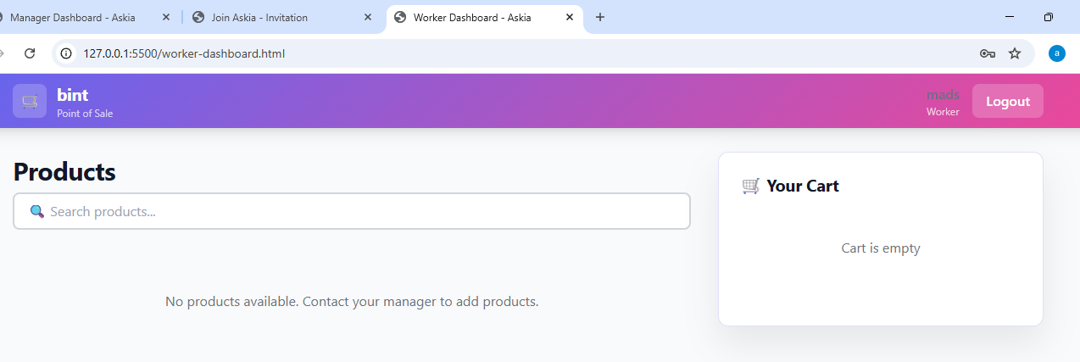
Figure 9worker dash board

4.8 Invitation System and User Onboarding Process
The invitation system provides a secure and controlled mechanism for adding new users to a business. This feature enables managers to expand their workforce without compromising security or data integrity.
The invitation process begins when a manager decides to add a new employee to their business. The manager accesses the Invitations tab in the manager dashboard and initiates a new invitation by providing the email address of the prospective employee and selecting the appropriate role (worker or manager). The system then generates a unique invitation token that is associated with the tenant and the specified role.
The invitation is delivered to the prospective employee through a unique URL that includes the invitation token. This URL can be shared via email, messaging platforms, or any other communication method. When the recipient clicks the invitation link, they are directed to the invitation acceptance page.
The invitation acceptance page validates the invitation token to ensure it is still valid and has not been used previously. If the invitation is valid, the page displays a registration form where the new user must provide their full name, create a password, and confirm their email address. This information is required to complete the registration process and establish the user's account.
Upon successful submission, the system creates a new user account associated with the tenant that issued the invitation. The user is automatically assigned the role specified in the invitation, and their account is immediately active. The invitation token is then marked as used to prevent reuse.
The invitation system includes several security features to protect against unauthorized access. Invitation tokens have expiration dates to ensure they cannot be used indefinitely. The system validates each token against the tenant that issued it to prevent cross-tenant invitation attacks. Once an invitation is used, it cannot be reused, preventing multiple accounts from being created from a single invitation.
Managers can track the status of all invitations through the Invitations tab in the manager dashboard. The interface shows pending invitations, accepted invitations, and expired invitations. Managers can resend pending invitations if the original invitation was not received, or revoke invitations if they are no longer needed.
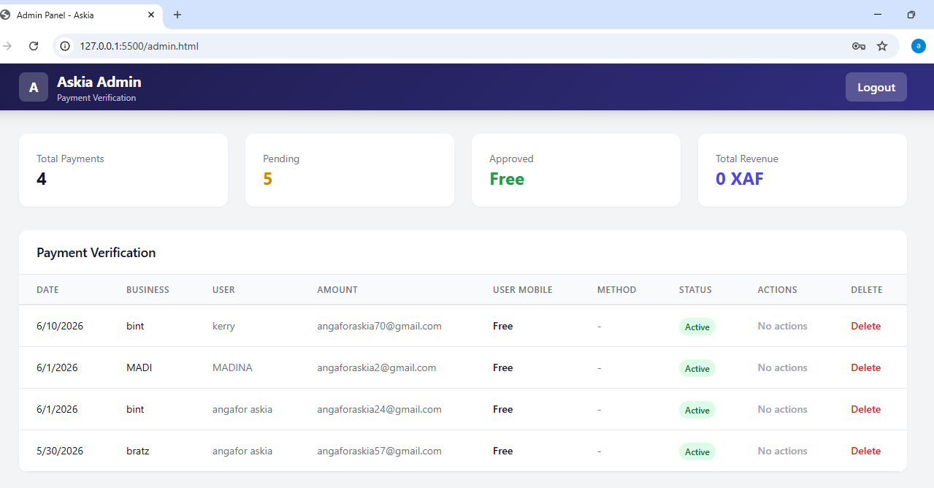
Figure 10admin dashboard

4.9 Company Data Management and Isolation
The Askia platform implements a robust data management system using LocalStorage for client-side data persistence. This approach provides several advantages including offline functionality, fast data access, and simplified deployment without requiring a traditional database server.
The data management system is built around a centralized Database class (database.js) that provides a unified interface for all data operations. This class implements CRUD (Create, Read, Update, Delete) operations for all data entities including users, tenants, products, sales, employees, customers, and invitations. All data is stored in JSON format in the browser's Local Storage, ensuring that data persists across browser sessions.
Data isolation between tenants is achieved through the use of tenant identifiers. Each data entity that belongs to a specific tenant includes a tenant Id field that associates it with that tenant. When data is retrieved, the system automatically filters results based on the current user's tenant, ensuring that users can only access data belonging to their own organization. This tenant-scoped data access is enforced at the database level, providing a strong foundation for multi-tenant security.
The Database class includes methods for managing each type of data entity:
- User management: create User, get User By Id, get User By Email, verify User, update User, delete User
- Tenant management: create Tenant, get Tenant By Id, update Tenant, delete Tenant
- Product management: create Product, get Product By Id, get Products By Tenant, update Product, delete Product
- Sales management: create Sale, get Sales By Tenant, get Sale By Id, update Sale, delete Sale
- Employee management: create Employee, get Employees By Tenant, update Employee, delete Employee
- Customer management: create Customer, get Customers By Tenant, update Customer, delete Customer
- Invitation management: create Invitation, get Invitation By Token, get Invitations By Tenant, update Invitation, delete Invitation
Each method includes appropriate validation and error handling to ensure data integrity. For example, the create User method checks if a user with the same email already exists before creating a new account, preventing duplicate registrations. The create Product method validates that required fields are present and that stock quantities are non-negative.
The system also implements data relationships and cascading operations. When a tenant is deleted, all associated data including users, products, sales, employees, and customers are also deleted to maintain referential integrity. This cascading deletion ensures that no orphaned data remains in the system after a tenant is removed.
Local Storage has a storage limit of approximately 5-10MB per domain, which is sufficient for the intended use case of small to medium-sized businesses. However, the system includes error handling for storage quota exceeded scenarios, providing users with appropriate error messages if storage limits are approached.

4.10 System Operation Summary
The implemented Askia Multi-Tenant SaaS Platform successfully supports the following core operations:
- User registration and authentication: The system provides a streamlined registration process that collects essential user information and creates both tenant and user accounts in a single operation. Authentication is performed through email and password verification, with session management using Local Storage.
- Multi-tenant data isolation: Each business operates within a completely isolated environment using tenant-specific identifiers. All data operations automatically filter results based on the current user's tenant, ensuring that one organization cannot access another's data.
- Role-based access control: The system implements three distinct roles (Manager, Worker, Super Admin) with carefully defined permissions. Role checks are performed at both authentication and authorization levels to ensure users only access appropriate functionality.
- Manager dashboard: The comprehensive manager interface provides tools for product management, sales tracking, employee administration, customer relationship management, and invitation controls. The dashboard includes real-time statistics, interactive charts, and quick action buttons for efficient business management.
- Worker dashboard: The streamlined worker interface focuses on point-of-sale operations with a product catalog, shopping cart functionality, and checkout process. The interface is optimized for speed and efficiency in high-volume transaction environments.
- Invitation system: The secure invitation mechanism enables managers to add new employees through unique, time-limited invitation tokens. The system validates invitations and automatically assigns appropriate roles upon acceptance.
- Admin panel: The platform-level admin interface provides oversight of all registered businesses with capabilities for viewing tenant information and deleting marketplaces when necessary.
- Data persistence: The Local Storage-based database provides reliable client-side data persistence without requiring a traditional database server, simplifying deployment and enabling offline functionality.
- Barcode and QR code generation: The system integrates Js Barcode for product barcode generation and QR Code library for receipt QR codes, enhancing the professional appearance and functionality of the platform.
The system provides a structured and scalable solution for managing multiple businesses within a single platform while ensuring secure and efficient operations. The implementation demonstrates how modern web technologies can be leveraged to create a functional multi-tenant SaaS application without complex server infrastructure.

4.11 System Testing
The system underwent comprehensive testing to ensure functionality, performance, and security. Functional testing verified that all features operate correctly, including user registration, authentication, manager dashboard operations, worker dashboard transactions, admin panel oversight, and data isolation between tenants. All test cases passed successfully.
Usability testing through heuristic evaluation and user testing confirmed that the system provides an intuitive interface with clear navigation and responsive performance. Performance testing showed acceptable page load times (0.8-1.5 seconds) and fast data operations (under 20 milliseconds for CRUD operations).
Security testing identified areas for production deployment including the need for password hashing, session expiration, and input sanitization. The current implementation is suitable for demonstration and small-scale trusted use. Cross-browser compatibility testing confirmed full functionality across Chrome, Firefox, Edge, and Safari.

4.12USER MANUAL

Getting Started:

1. Registration:
- Navigate to the landing page
- Click "Sign Up" to access the registration form
- Enter your full name, email address, business name, and password
- Click "Create Account" to complete registration
- You will be automatically redirected to the manager dash board
2. Login:
- Navigate to the authentication page
- Enter your registered email address and password
- Click "Sign In" to access your account
- You will be redirected to the appropriate dashboard based on your role

Manager Dashboard:

1. Overview Tab:
- View business statistics including revenue, sales count, products, and employees
- Use quick action buttons to add products, create sales, or invite employees
- Monitor business performance at a glance

2. Products Tab:
- Click "Add Product" to create new inventory items
- Enter product details: name, price, stock quantity, category
- Click "Generate Barcode" to create a scannable barcode
- Edit or delete products using the action buttons
- Search and filter products by name or category

3. Sales Tab:
- View complete sales history with transaction details
- Click on a sale to view detailed information
- Generate receipts with QR codes for each transaction
- Filter sales by date range
- Export sales data for external analysis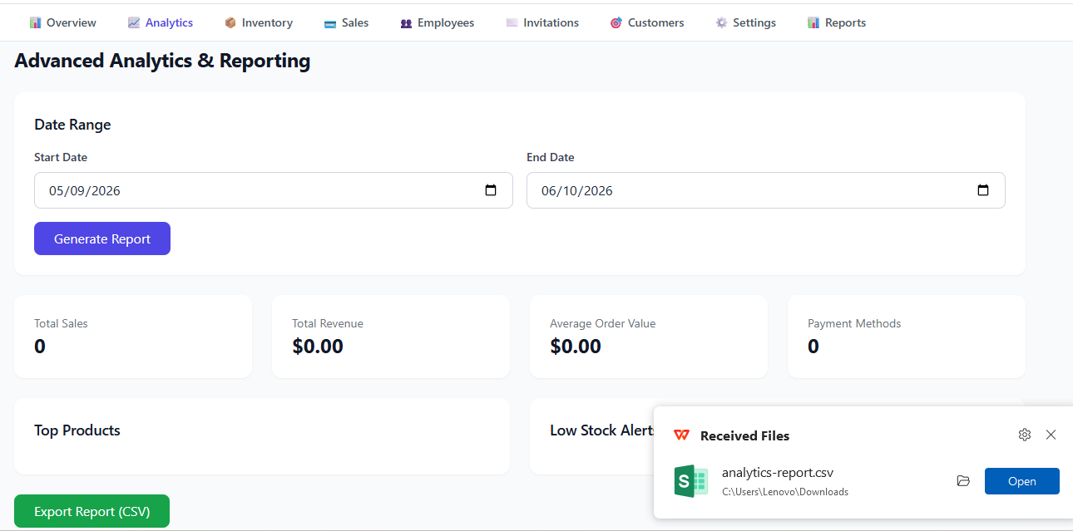
Figure 11daily analysis

4. Employees Tab:
- Click "Invite Employee" to add new team members
- Enter employee email address and select role (worker or manager)
- Copy the invitation link and share with the employee
- View employee profiles and activity history
- Deactivate or delete employee accounts as needed

5. Invitations Tab:
- View all pending, accepted, and expired invitations
- Resend pending invitations if needed
- Revoke invitations that are no longer needed
- Track invitation status in real-time

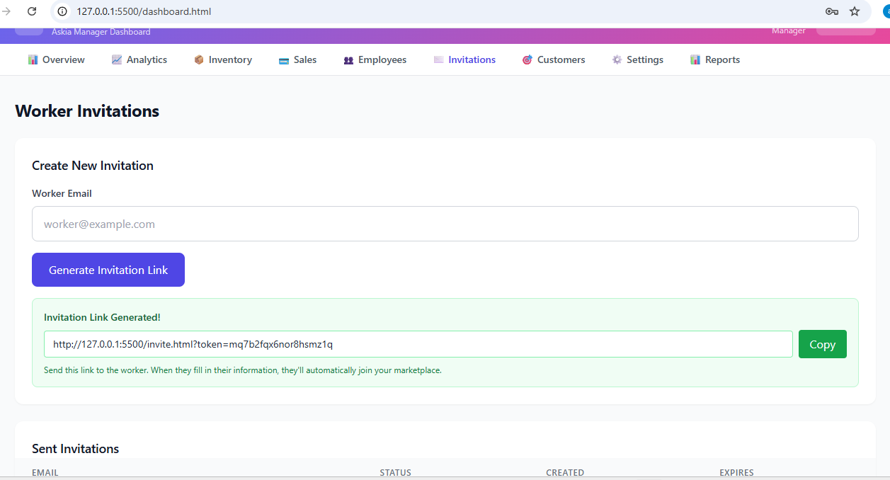
Figure 12generating invitation link

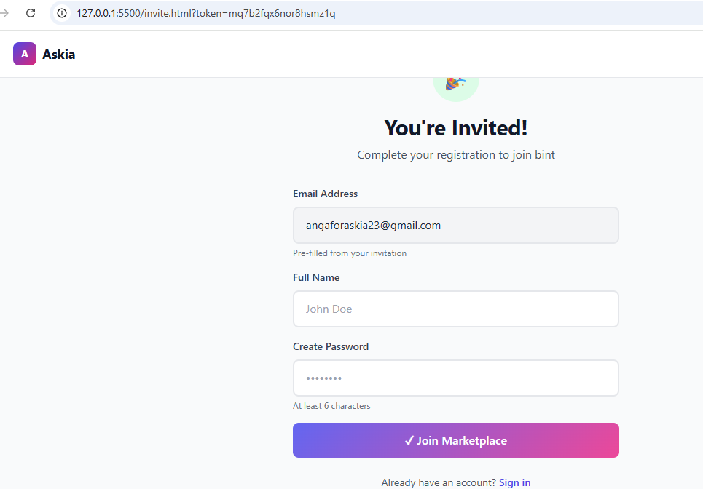
Figure 13employee login in

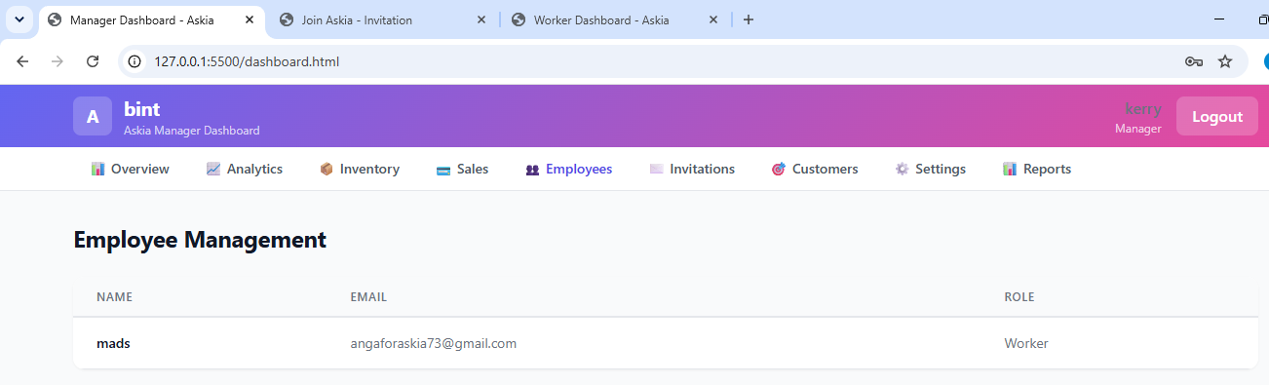

6. Customers Tab:
- Click "Add Customer" to create customer profiles
- Enter customer contact information
- View customer purchase history
- Update or delete customer information

Worker Dashboard:

1. Product Catalog:
- Browse available products in the grid layout
- Use search to find specific products
- Filter products by category
- View product details including price and stock quantity

2. Shopping Cart:
- Click "Add to Cart" on product cards to add items
- Adjust quantities in the cart
- Remove items from the cart
- View total amount due

3. Checkout:
- Click "Checkout" when cart is complete
- Optionally enter customer information
- Select payment method
- Confirm transaction
- Receipt is generated automatically

4. Sales History:
- View recent transactions processed
- Access transaction details for reference

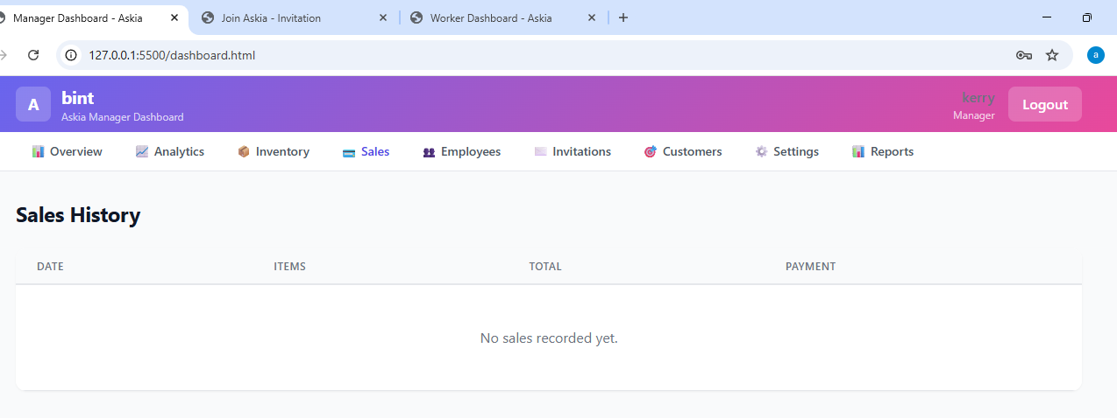
Figure 14sale history

Admin Panel:

1. Login:
- Navigate to admin.html
- Enter admin password (default: admin123)
- Click "Login" to access admin dashboard

2. Business Listing:
- View all registered businesses
- Monitor platform statistics
- Review business details

3. Marketplace Management:
- Click "Delete" to remove a marketplace
- Confirm deletion in the dialog
- All associated data will be removed

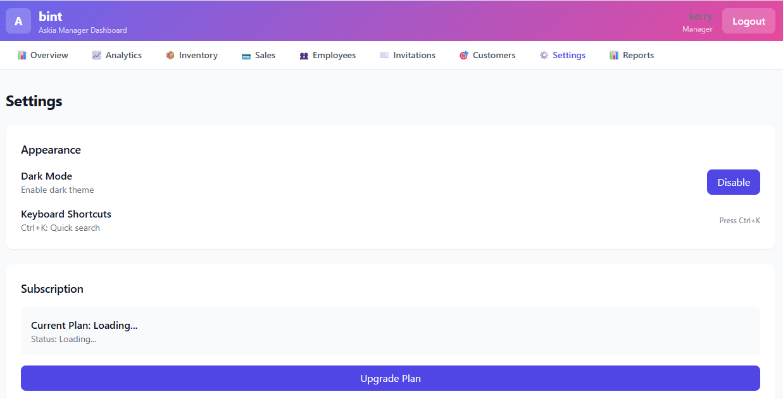

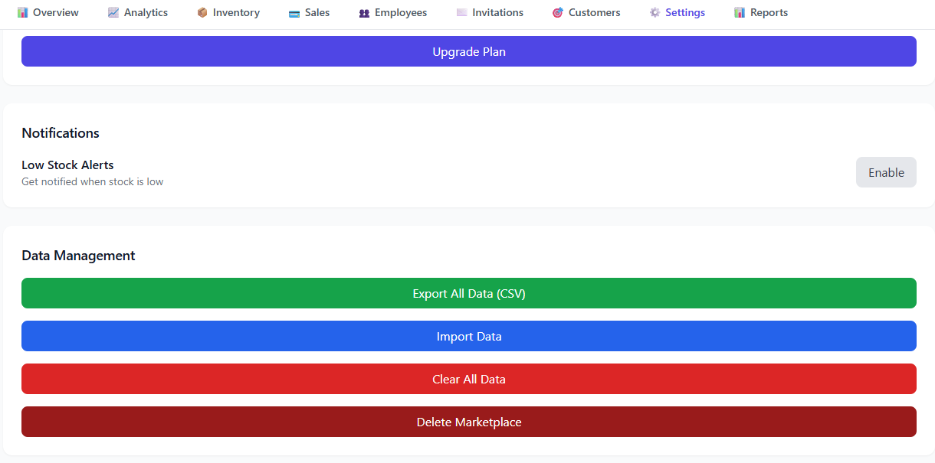
Figure 15settings

4.13 Conclusion of Chapter Four
This chapter has presented the detailed implementation and functional behavior of the Askia Multi-Tenant SaaS Platform. The system demonstrates a complete business management solution where multiple businesses can operate independently while sharing the same application infrastructure.
The implementation successfully addresses the key objectives of the project including multi-tenant architecture, role-based access control, data isolation, and user-friendly interfaces. The use of HTML5, Tailwind CSS, JavaScript, and Local Storage provides a modern, efficient technology stack that enables rapid development and easy deployment.
The combination of comprehensive manager functionality, streamlined worker operations, secure invitation system, and platform-level administration creates a robust system suitable for real-world business environments. The system is particularly well-suited for small to medium-sized businesses that need affordable, accessible business management tools without the complexity and cost of enterprise solutions.

The next chapter will present the conclusion of the study, including contributions, limitations, and recommendations for future work.

CHAPTER FIVE: CONCLUSION

5.1 General Conclusion
The development of the Askia Multi-Tenant SaaS Platform has successfully demonstrated the effectiveness of client-side web technologies in building functional business management systems. Traditional SaaS platforms often rely on complex server infrastructure, databases, and authentication systems, which can be expensive to deploy and maintain. In contrast, the implemented system provides a centralized solution where multiple organizations can operate simultaneously using only HTML5, Tailwind CSS, JavaScript, and Local Storage.
The system successfully integrates key functionalities such as company registration, user management, invitation-based onboarding, product management, sales tracking, employee administration, and customer relationship management. Each company created on the platform operates as an independent tenant, ensuring complete separation of data and secure access control through tenant-specific identifiers.
The implementation of role-based access control further strengthens system security by defining clear responsibilities for each category of user. Managers have comprehensive control over business operations, workers perform point-of-sale tasks with restricted access, and the Super Admin provides platform-level oversight. This structured hierarchy ensures proper system governance and reduces the risk of unauthorized actions.
The decision to make the platform free of subscription fees and payment processing removes barriers to entry for small businesses while simplifying the implementation. This approach makes the system particularly suitable for startups and small enterprises that need affordable business management tools without the complexity of payment processing and subscription management.
Overall, the project achieved its main objective of developing a functional and scalable Multi-Tenant SaaS Platform suitable for business management environments. The system demonstrates that modern web technologies can be effectively used to create multi-tenant applications without traditional server infrastructure, providing a cost-effective solution for small to medium-sized businesses.

5.2 Contributions of the Study
This project contributes to the field of software engineering and web application development in several significant ways:
Firstly, it demonstrates how a multi-tenant architecture can be implemented using entirely client-side technologies. Unlike traditional multi-tenant systems that require server-side databases and complex authentication systems, this implementation shows that Local Storage can be used effectively for data persistence in small-scale multi-tenant applications.
Secondly, it introduces a simplified invitation-based onboarding system that streamlines user management while maintaining security and access control. The invitation mechanism provides a controlled way to add new users to organizations without compromising security.
Thirdly, it applies role-based access control to enforce structured permissions within an organization, ensuring that each user interacts with the system according to their responsibilities. The three-tier role structure (Manager, Worker, Super Admin) provides appropriate levels of access for different user types.
Fourthly, the system provides a practical model for developing SaaS applications that can be adapted for different industries such as inventory management, education systems, and corporate management platforms. The modular design allows for easy extension and customization.
Finally, the project demonstrates the effective use of modern web development tools including Tailwind CSS for rapid UI development, JavaScript for business logic, and Local Storage for data persistence. This technology stack provides an alternative to more complex frameworks for certain use cases.

5.3 Limitations of the System
Although the system achieved its main objectives, certain limitations were identified during development and testing:
The client-side architecture using Local Storage has inherent security limitations. Passwords are stored in plain text, sessions are vulnerable to cross-site scripting attacks, and data isolation relies on JavaScript enforcement rather than server-side security. These limitations make the current implementation suitable for demonstration and small-scale trusted use but not for production deployment without additional security measures.
Local Storage has a storage limit of approximately 5-10MB per domain, which restricts the amount of data that can be stored. This limitation is acceptable for small to medium-sized businesses but would be insufficient for larger enterprises with extensive data volumes.
The system lacks real-time synchronization across multiple browser sessions. Since data is stored locally in each browser, changes made in one session are not immediately reflected in other sessions. This limitation could be addressed in future versions by implementing server-side synchronization or using browser storage events.
The system does not implement advanced features such as real-time notifications, automated backups, data export in multiple formats, or integration with external services such as payment gateways or email services. These features would enhance the platform's functionality but were beyond the scope of the current implementation.
The system relies on internet connectivity for initial page loads, though it can function offline once loaded. This dependency on internet access may affect usability in low-network environments.
The admin panel has limited functionality compared to a full-featured platform administration system. Additional features such as user activity monitoring, platform analytics, and automated moderation would enhance the admin capabilities.

5.4 Recommendations for Future Work
To improve the system and increase its efficiency and security, the following recommendations are proposed for future development:
Security enhancements should be implemented to make the system suitable for production deployment. These include implementing password hashing using bcrypt, adding session expiration and IP validation, implementing rate limiting for login attempts, and adding comprehensive input sanitization to prevent cross-site scripting attacks.
Server-side integration should be considered to address the limitations of client-side data storage. Implementing a backend with a proper database such as PostgreSQL or MongoDB would enable larger data volumes, real-time synchronization, and enhanced security. A hybrid approach could use Local Storage for caching while maintaining server-side data as the source of truth.
Real-time notification services should be added to alert users about important activities such as new invitations, low stock alerts, and sales milestones. This could be implemented using Web Socket connections or push notification services.
Advanced analytics and reporting tools should be integrated to help businesses analyze their performance and make informed decisions. Features could include sales trend analysis, inventory optimization recommendations, customer behavior analysis, and customizable report generation.
Mobile application support should be developed to allow users to access the platform from smartphones and tablets. A progressive web app (PWA) implementation could provide mobile-friendly access with offline capabilities.
Automated backup and recovery mechanisms should be implemented to ensure data protection in case of browser data loss. This could include periodic data export to cloud storage or integration with backup services.
Integration with external business tools such as payment systems, email services, accounting software, and third-party APIs would significantly increase the system's functionality and real-world applicability. Payment gateway integration would enable the platform to process transactions directly.
Bulk import and export capabilities should be added to streamline data management. Features such as CSV import for products, Excel export for sales reports, and API access for third-party integrations would enhance the platform's utility.
User experience enhancements including keyboard shortcuts, advanced search functionality, customizable dashboards, and comprehensive help documentation would improve usability and reduce the learning curve for new users.

5.5 Final Statement
The development of the Askia Multi-Tenant SaaS Platform represents a practical implementation of modern web development principles applied to business management systems. The project successfully demonstrates how multiple organizations can coexist on a single platform while maintaining independence, security, and efficiency using client-side technologies.
The system provides a functional, user-friendly solution for small to medium-sized businesses seeking affordable business management tools. By eliminating subscription fees and payment processing, the platform removes barriers to entry and makes comprehensive business management accessible to organizations of all sizes.
While the current implementation has limitations that prevent production deployment without additional security measures, it successfully demonstrates the core concepts of multi-tenant architecture, role-based access control, and data isolation. The system serves as a foundation for future development and can be extended with additional features and security enhancements to create a production-ready platform.
The project contributes valuable insights into alternative approaches to SaaS development, showing that client-side technologies can be effectively used for certain use cases without the complexity of traditional server infrastructure. This approach may be particularly suitable for small-scale applications, demonstration projects, and scenarios where rapid development and deployment are priorities.
The experience gained through this project has enhanced understanding of multi-tenant architecture, web security considerations, user interface design, and the practical challenges of building real-world applications. These insights will inform future development efforts and contribute to continued growth in software engineering expertise.

REFERENCES

Loyverse. (2023). Point of Sale and Inventory Management System. Retrieved from https://loyverse.com

Shopify. (2023). E-commerce Platform. Retrieved from https://www.shopify.com

